GET A FREE ACE COLOR CHANGING CUP AT THE NEXT

ABBOTTS CREEK ELEMENTARY SPIRIT NIGHT

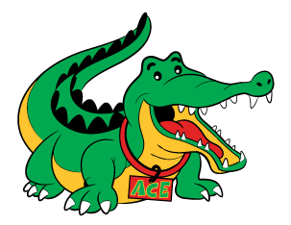
MONDAY, JANUARY 30, 2017
Dine In and Take Out – 8853 Six Forks Rd., Raleigh
5:00 p.m. – 10:00 p.m.

Be sure to mention Abbotts Creek and
the school will receive a percentage of your purchase. ACE cups will be awarded to all participants!

GET A FREE ACE COLOR CHANGING CUP AT THE NEXT

ABBOTTS CREEK ELEMENTARY SPIRIT NIGHT

MONDAY, JANUARY 30, 2017
Dine In and Take Out – 8853 Six Forks Rd., Raleigh
5:00 p.m. – 10:00 p.m.

Be sure to mention Abbotts Creek and
the school will receive a percentage of your purchase. ACE cups will be awarded to all participants!

