ABBOTTS CREEK ELEMENTARY SPIRIT NIGHT

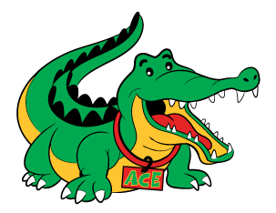 | 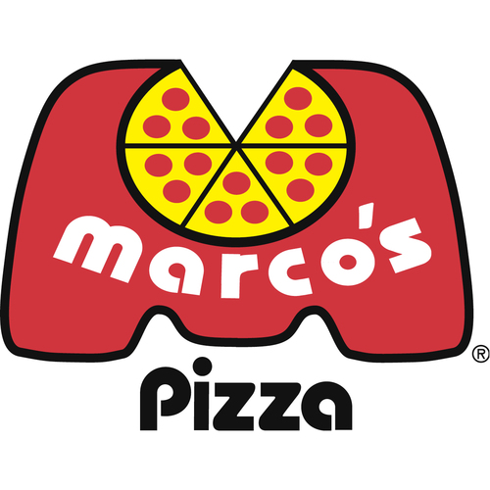
TUESDAY, DECEMBER 12, 2017
Takeout and Delivery - 1141 Falls River Avenue, Raleigh
4:00 p.m. – 10:00 p.m.

Call (919) 847-7775

Be sure to mention Abbotts Creek and
the school will receive 15% of your purchase.

ABBOTTS CREEK ELEMENTARY SPIRIT NIGHT

TUESDAY, DECEMBER 12, 2017
Takeout and Delivery – 1141 Falls River Avenue, Raleigh
4:00 p.m. – 10:00 p.m.

Call (919) 847-7775

Be sure to mention Abbotts Creek and
the school will receive 15% of your purchase.

