ACES PTA Board Meeting (11/08/2016)

December 8th, 2016 Board Meeting Minutes
5:00pm General Meeting Minutes

Officer Reports
Attendees – Laura Bowman, Mary Mudryk, Sue Reynolds, Paula Trantham, Brian Imfeld, Jody Bulmer

President
- Book Fair
  - We should have close to $9000 in scholastic dollars, as the fair took in over $15k. This is 3-4K more than last year.
  - We do need to decide if we are using these scholastic dollars or asking for cash back – Will discuss with Mr. Hamilton and let him make decision. Discussed challenges with Book Fair and how to improve next year.
  - BOGO Book Fair will be on April 3rd w/ an evening Choir performance & PTA Meeting
- Newsletter will go out on December 15th or 16th. It will be a summary of what we’ve been doing, it won’t be as large as the newsletters typically are. Information about Wake Up and Read will be in the newsletter.
- Next Board meeting is on 1/06 at 6:30pm
- Welcome to our World will be held on February 16.
- Next and final General PTA meeting is on April 3rd and will include the introduction and voting for 2016-17 BOD
- Grant approvals – Need to send teachers date for when they must have grants turned in – end of January for teacher support funds and then we will know how much is remaining in the budget for curriculum grants. Curriculum grants will be due 2/15/17. If teachers have Donors Choose accounts, the PTA can post and advertise them.
- The board unanimously approved Sue Reynolds to lead the Nominating committee

Vice President (Fundraising)
- The Fun Run total is right at $27K. It’s about 3K short from the goal.
- Shade Structure Update – Jill will get a list of contractors and start pricing them out. The goal is to have all the information and decisions made by the end of January so we can have an install date.
- Restaurant Nights - new ACES color change cups will be present at future restaurant nights
  - Sweet Tomatoes ($336 earned)
  - Marco’s Pizza (December 14th) – Tina Gordon will have flyers in Tuesday folders next week.
  - Milton’s (January 30th) – Cups will definitely be given out at Milton’s since the location is a place where the families can come together.
- Chorus performing at Barnes and Noble in Triangle Town on 12/16 - this will be a fundraiser, as B&N will give a portion of sales back to ACES for purchases made during the performance or online for up to a week after the performance!
- Greenway Club “fundraiser”?? – Last year we sent home a flyer about joining the club and the club gave back $50 to the school. Will likely send a message on Social Media to contact Liz Miller at the Greenway Club if interested in joining and complete paperwork. No flyers will be sent home.

Vice President (Hospitality & Volunteering)
- Teacher Appreciation Updates
  - 12/21 (Teacher Appreciation Holiday Dessert Bar) from 11:00am to 1:00pm – we are asking for donations from local businesses
    - Plan is for event to take place in the conference room
    - Talked about options for Teacher Appreciation days next year
  - 01/20 (School Supply for Teacher)

Vice President (Communication)
- Jodi will be stepping down at VP of Communication, as much of that role is being handled by Laura this year, Jodi will however be joining Suzi on our Advocacy Committee!!

Treasurer
- Books are up to date and audited through November – everything looks great!
- 990 has been submitted to the IRS and NCPTA
- Current bank total is $39, 203.76, with a @ $1500 deposit ready for the bank
- Finances reported at last General PTA Meeting (see screenshot)
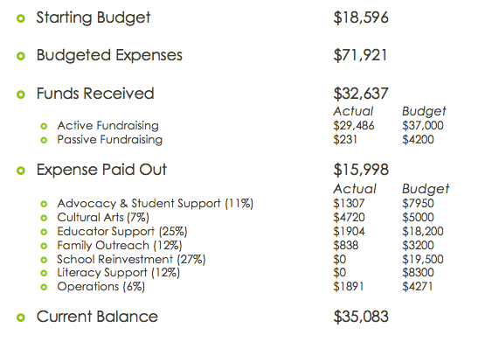
At-Large
- Membership
  - Currently 246 members in the database - 54 to go to meet our yearly goal!
- Spirit Wear
  - All spirit wear has been distributed! Huge thanks to Scott for all his hard work!
  - Car Magnets have been delivered
    - Will be sold at Welcome to our World, the Milton’s Spirit Night, etc

Committee Reports

Audit Committee
- Audit’s completed through November.
- October audit found that not everyone is attaching a check request form to invoices that need to be paid. It is required that we attach the request for even if it’s an invoice to pay the spiritwear vendor, etc.

Advocacy Committee
- 45 students received holiday supply bags during Fall Break
- 76 students are participating in the Giving Tree this year - all students have been accounted for
- It’s time to move the lost and found out of ACES - anything still in Lost and Found on 12/16 will be offered to our counselors for ACES students in need and then taken to Note in the Pocket.
- Wake Up and Read kicks off on January 21st, ACES will collect from 1/21 to 2/14 for “Have a Heart, Give a Book”
- Marlo Gaddis is coming to WMMS to speak about Internet Safety – on Feb 2 at 6:30p. This is just being hosted at WMMS – all district 3/northern area schools are being invited and encouraged to attend the presentation. Marlo is an amazing speaker and this will be a great session for parents to listen, learn and ask questions about what kids today face with online access.

Cultural Arts
- Leni Newell project was a great success! First year the project will hang vertically, the next year horizontally. The installation funding need is $460 and then someone will have to be paid to put it up ($250)
- Next performance will be on March 24th - Origami Tales
- Additionally, we did win a grant for an additional performance. Susan and Laura are working through the details on which performance will come to ACES
- 5K in budget, have spent $4,700. Discussed options to pay for Leni Newell project – the extra $430.

Nominating Committee
- Susan Reynolds will chair the Nominating Committee this year.
- Danielle Kestnbaum and Lauren Jones have volunteered to be on the committee as well. We made an announcement at the last PTA meeting + blog post for additional interest.
- We will need to publicize that the committee is seeking interested parties to be on next years board.

Reflections Update
- ACES had 14 participants this year, all were sent to the County to be judged. We did not have any students who placed in the County level.

Other Reports

Principal/Teachers
- Discussed ensuring that Pre-K and Special Ed classes receive all event communication, have been a few issues where they have not received information.

Adjourn Meeting
6:20pm

