BE A GATOR SKATER!
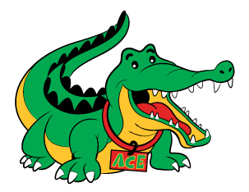
SAVE THE DATE FOR A SUMMER SPIRIT SKATE

Saturday, July 29 – 12:30 p.m. – 3:00 p.m.

Polar Ice House Wake Forest
1839 South Main Street, Wake Forest, NC

Take a break from the summer heat & cool off with your fellow Gators. Bring warm clothes, gloves & cash for fun, valuable raffle prizes.
Abbotts Creek gets 25% of all skating fees during this time frame, as well as proceeds from raffles. Bring your friends!

BE A GATOR SKATER!
SAVE THE DATE FOR A SUMMER SPIRIT SKATE

Saturday, July 29 – 12:30 p.m. – 3:00 p.m.

Polar Ice House Wake Forest
1839 South Main Street, Wake Forest, NC

Take a break from the summer heat & cool off with your fellow Gators. Bring warm clothes, gloves & cash for fun, valuable raffle prizes.
Abbotts Creek gets 25% of all skating fees during this time frame, as well as proceeds from raffles. Bring your friends!

